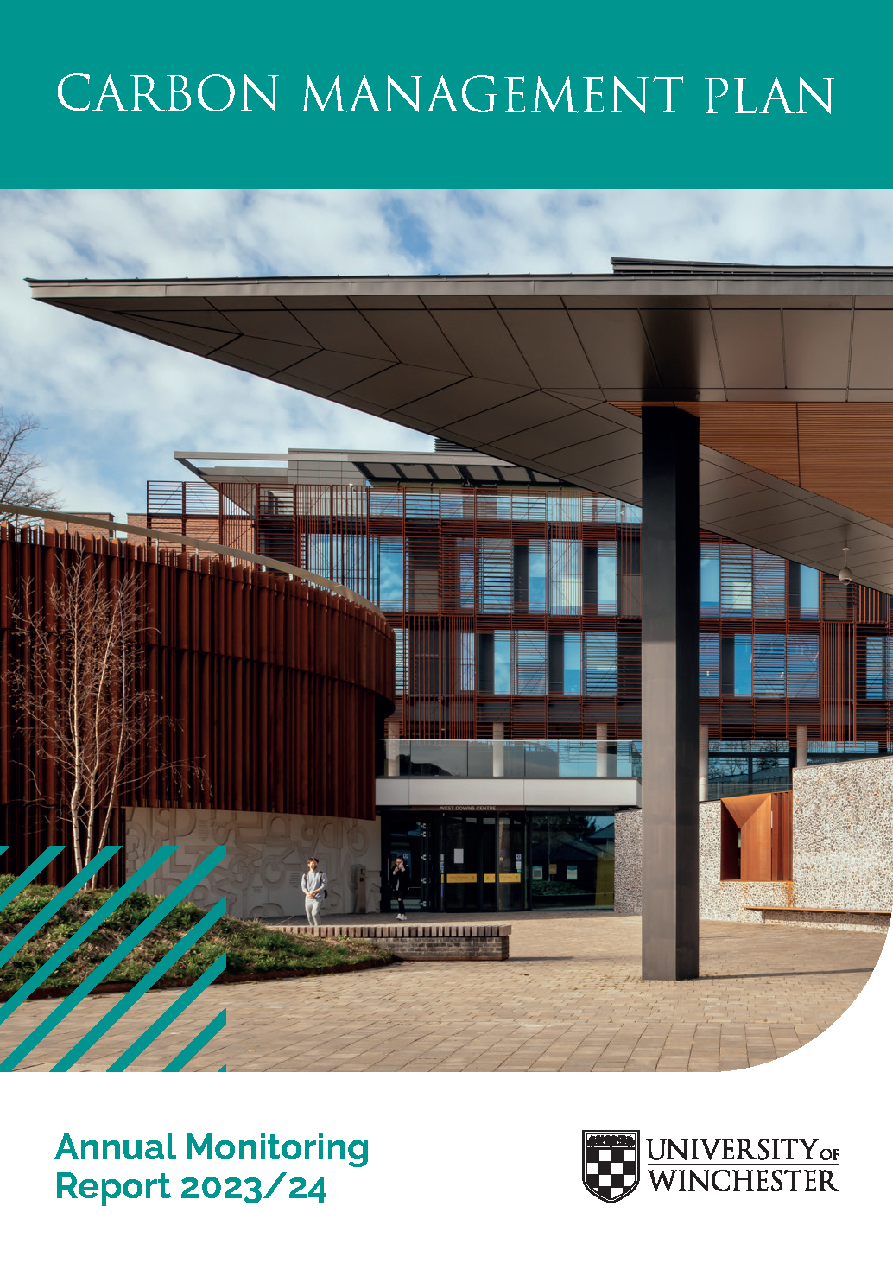
Document Title: | Carbon Management Plan Annual Monitoring Report 2023/24
Document Author: | Laura Dale – Environment & Sustainability Manager
Responsible Person and Department: | Mat Jane – Head of Environment and Building Services
Approving Body: | University Leadership Team (ULT)
Date of Approval: | March 2025
Date Effective From: | March 2025
Review Date: | March 2026
Indicate whether the document is for public access or internal access only  Indicate whether the document applies to collaborative provision?  (Strikethrough text, as appropriate) | Public Access
Summary:

This report details progress against targets set in the University of Winchester Carbon Management Plan for the year 2023/24.

Contents
EXECUTIVE SUMMARY 4
INTRODUCTION 5
CLIMATE EMERGENCY 5
UNIVERSITY OF WINCHESTER TARGETS 6
NET ZERO TARGETS 6
CARBON MANAGEMENT PLAN – TARGETS 7
UNIVERSITY OF WINCHESTER CARBON FOOTPRINT 2022/23 8
SCOPE, BOUNDARY AND REPORTED EMISSIONS 8
SCOPE 1 & 2 EMISSIONS 9
SCOPE 1 AND 2 ENERGY EMISSIONS - LOCATION BASED REPORTING 11
SCOPE 1 AND 2 ENERGY EMISSIONS - MARKET BASED REPORTING 11
MARKET VS LOCATION BASED REPORTING 12
SCOPE 1 AND 2 EMISSIONS AVOIDED 13
ESTATE BUILDING EFFICIENCY 13
SCOPE 3 EMISSIONS 14
TOTAL REPORTED CARBON EMISSIONS (LOCATION BASED) 15
CONCLUSION & LOOKING FORWARD 17
APPENDIX ONE 19

EXECUTIVE SUMMARY
This report details progress against targets set in the University of Winchester Carbon Management Plan. To avoid an overly long document, only key headline achievements and areas of concern are covered.

Key Points
- Continued reductions in carbon emissions in absolute terms compared to baseline and relative to the size of the estate.
- Carbon emissions intensity by floor area reduction target for scope 1 & 2 by 2025 already exceeded.
- On track for achieving carbon emissions reduction 2030 target for scope 1, 2 & measured scope 3 emissions.
- Further work needed for full scope 3 measuring and reporting.

Area | Description | Progress by  (2022/23) 2023/24 | Target | By When
Carbon | Total Carbon Emissions for Scope 1 & 2 | -46% | -55% | 2030
Carbon | Carbon Emissions (Scope 1 & 2) Intensity by Floor Area | -69% | -65% | 2025
Carbon | Total Carbon Emissions for Scope 1, 2 & known scope 3 (water, waste & business travel) | -44% | -55% | 2030

INTRODUCTION

This report details progress against targets set in the University of Winchester Carbon Management Plan, the baseline year for the Carbon management Programme is the 2006/7 academic year, against which all carbon data is measured. The information within the document is for the 2023/24 academic year.

CLIMATE EMERGENCY

In September 2019, the university declared a climate emergency. This followed the publication in May 2019 of the Committee on Climate Change (CCC) comprehensive report ‘Net Zero –The UK’s contribution to stopping global warming’, advising the UK government to set a net-zero carbon emissions target by 2050. As a result, the UK set a net-zero target in June 2019. Several reports since then have underlined the need to act rapidly on climate change. This includes the WMO ‘Provisional State of Global Climate 2023’, showing that the last 9 years (2014-2023) are the nine warmest years on record, fuelled by ever-rising greenhouse gas concentrations and accumulated heat.
IPCC released its sixth assessment report in 2021 which concluded that climate change is widespread, rapid and intensifying. To limit warming to 1.5°C, global carbon dioxide emissions must be reduce by about 45% by 2030 and net-zero must be achieved by 2050.
A follow-up report from IPCC issued in early 2023, highlights that achieving the 1.5°C goal requires immediate and unprecedented reductions in emissions.
In the 2023 UN’s Emissions Gap Report the UN Environment Programme (UNEP) stated that the world is still on track for a global temperature rise of 2.8°C by the end of the century, far above the 1.5°C target.
The coming years are critical, with 2030 serving as a pivotal deadline for reducing emissions in line with the reduction target and avoiding the most catastrophic impacts of climate change.
The UK announced at COP29 that the UK’s 20235 Nationally Determined Contribution (NDC) emissions reduction target was at least 81% below 1990 levels.
The university is a signatory to the SDG Accord –a global higher education accord overseen by the EAUC and other international academic bodies designed to support the advancement of the Sustainable Development Goals (SDGs). This commits the University to aligning its operations with the SDGs and to supporting the target to become Net Zero Carbon by 2030.
The next step in our carbon reduction journey is for the university to build a detailed roadmap to understand how this target will be achieved at the University of Winchester.

UNIVERSITY OF WINCHESTER TARGETS

NET ZERO TARGETS

The University of Winchester has committed to being Net-Zero* by 2030 (*for scope 1, 2 and part scope 3 emissions). The university has been successful in reducing Scope 1 and 2 emissions by 77% since our baseline year of 2006. This has been achieved by reducing energy consumption on campus, purchasing zero carbon electricity & REGO certificates and switching to an electric fleet. A £3.2 million capital programme funded by the PSDS (Public Sector Decarbonisation Fund) saw the implementation of numerous energy saving measures in 2021/22 which has contributed to a significant reduction in gas emissions on site and lower energy consumption overall.
Those emissions which cannot be realistically reduced or avoided, which are mostly Scope 3 emissions, will then be offset through funding an equivalent amount of carbon offsets through a certified emissions offsetting scheme. In 2021, the University ran a trial and purchased its first carbon offsets via the EAUC Carbon Coalition for our 2019/20 emissions covering our Scope 1 and 2 emissions and those Scope 3 emissions we directly control (business travel, waste and water consumption).
In 2020/21, the University also published its Scope 3 Gap Analysis Report which provided the first measurement of the whole Scope 3 emission footprint. This highlighted the challenge ahead, with Scope 3 emissions comprising around 95% of the total carbon footprint. Further work is needed to identify and quantify all scope 3 sources that the university generates which are not currently accurately measured. Once the scope 3 emissions of the University have been fully quantified, the university Carbon Management Plan will be updated to reflect the change in scope of the plan and inform a further Net-Zero strategy for the currently unknown carbon footprint “plus” emissions.
Carbon footprint “plus” emissions are emissions arising from the following areas:
- Goods & services purchased by UoW
- Transport of goods to UoW
- Construction and refurbishment projects
- Student and Staff commuting
- Other travel to the UK
- Other business travel/ expenses
- Investments made by UoW
- Working from home by UoW staff and students
A “net-zero” target refers to reaching net-zero carbon emissions, but differs from zero carbon, which requires no carbon to be emitted.
Net-zero refers to balancing the amount of emitted greenhouse gases with the equivalent emissions that are either offset or sequestered. This should primarily be achieved through a rapid reduction in carbon emissions, but where zero carbon cannot be achieved, offsetting through carbon credits or sequestration through rewilding or carbon capture and storage needs to be utilised.

CARBON MANAGEMENT PLAN – TARGETS

The university created its initial Carbon Management Plan in 2006/07 and having achieved its initial 2015 targets of 30% reduction per m2, following a successful emissions reduction programme, a review of the CMP was undertaken and a revised plan was launched in September 2016. The revised 2015/16 CMP set new ambitious targets for reducing emissions to 2030, the targets approved in this plan were;
- 30% absolute carbon reduction against its 2006/07 baseline by 2020/21- (target exceeded with 40.4% reduction achieved in 20/21)
- 55% absolute carbon reduction against its 2006/07 baseline by 2030/31
- 65% carbon intensity reduction against its 2006/07 baseline by 2025/26
These targets are key to help in reducing the amount of CO2 the university generates and therefore reduce the amount of CO2 to offset to achieve Net-Zero by 2030.
The University of Winchester has committed to a long-range target of a 55% reduction by 2030, against a 2006/07 baseline. This target is based on total emissions (absolute) and is aligned with the level of decarbonisation required to limit global warming to 1.5°C. It will be a challenging target to achieve,
In order for the University of Winchester to demonstrate progress against its ambitious 55% reduction target, an emissions intensity target of a 65% reduction by 2025, against 2006/07, has also been set. This target has been designed to stretch the University in its efforts to deliver a low-carbon campus and deliver a challenging carbon reduction pathway aligned to the climate science.

Figure 1 – absolute carbon emissions (for scope 1, 2 & known scope 3) against the 55% reduction target by 2030

The above graph shows that the university is ahead of target for achieving the 2030 carbon reduction target of 55%. The University is exceeding our yearly target (39% reduction) by 5% for 2023/24, achieving a reduction on 44%.

UNIVERSITY OF WINCHESTER CARBON FOOTPRINT 2022/23

SCOPE, BOUNDARY AND REPORTED EMISSIONS

The infographic below shows the scope and boundary of the carbon footprint emissions covered in this report.
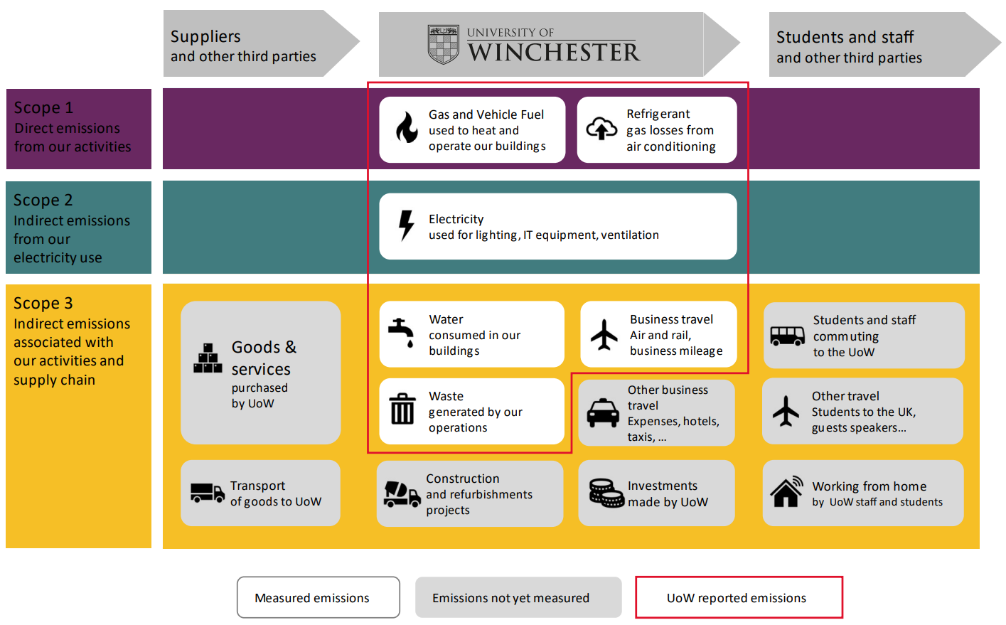

Figure 2 – Emissions scope and boundary

The following table shows the current emission levels from the sources being measured as part of the University of Winchester Carbon Management Plan. Further work is planned to increase the scope of the CMP to cover all Scope 3 emissions to inform a Carbon Footprint “plus” Plan including targets for reduction of the wider Scope 3 emissions. The table is based upon grid conversion factors and the location-based emissions approach rather than market-based emissions which make allowance for green energy procurement.

Type of Emissions | Emissions sources |  | Carbon Emissions 2006/7 Baseline Year  (tCO2e) | Carbon Emissions 2022/23  (tCO2e) | % Change
Scope 1  Direct emissions from our activities |  | Fossil Fuels  Fuels used to heat and operate our buildings  Vehicle fuels  Fleet vehicle fuel consumption  Refrigerant Losses  Losses from refrigerant based systems | 1,721 tCO2e  38.5 tCO2e  0 tCO2e | 821 tCO2e  6.8 tCO2e  0 tCO2e | -52 %  -82 %
Scope 2  Indirect emissions from our electricity use |  | Electricity  Used for lighting, IT, equipment, ventilation | 1,843 tCO2e | 1,139 tCO2e | -38 %
Scope 3  Other indirect emissions associated with our activities and supply chain |  | Water consumed  Water discharged to sewer  Waste generated  On campus  Construction projects  Business travel  Air and rail travel booked for business related work  Grey fleet usage | 26.3 tCO2e  437 tCO2e  145 tCO2e | 23.1 tCO2e  3.28 tCO2e  347 tCO2 | -12 %  -99 %  139 %
Total Emissions |  |  | 4,211 tCO2e | 2,341 tCO2e | -44 %

Figure 3 – Overall emissions by scope

SCOPE 1 & 2 EMISSIONS

LOCATION VS MARKET BASED EMISSIONS SCOPE 1 & 2

GHG Protocol reporting methodologies allow organisations to report two figures for carbon emissions from energy.
Location-based methodology reporting means that emissions from electricity and gas are based on the energy grid conversion factors for the chosen energy type (the UK grid average emissions intensity).
Market-based methodology reporting means that emissions from energy are determined by the emissions factor of the specific energy supplier and tariff being purchased- allowing organisations to demonstrate their commitment to the environment & carbon reduction through purchasing renewable energy.
The university has purchased zero carbon electricity to cover 100% of its demand since 2008/09, meaning that, under the market-based methodology, carbon emissions are much lower.
Between April 2022 and April 2024, the university had to switch the procurement of its electricity supply to a Zero Carbon for business tariff, backed by 100% nuclear generator declarations and zero carbon emissions. This move away from renewable was due to the high national demand of 100% renewable energy and limited supply of REGOs to cover this demand. The University returned to purchasing 100% renewable energy, backed by Renewable Energy Guarantees of Origin (REGOs) from wind, solar and/ or Hydro, from 1st April 2024
In 2019/20 the university also purchased 47% of its annual gas demand from renewable gas generation (biomethane). In the 2020/21 & 2021/22 reporting years the University increased its annual purchasing of renewable gas to 100%. Due to cost pressures the University were unable to continue with the purchase of renewable gas in 2022/23 and 2023/24. As such only 4% of the annual gas demand was from renewable sources in 2022/23 and 0% from renewable sources in 2023/24. Rather than continue to fund the extra cost for green gas, the university have made the decision to invest the extra funds into infrastructure changes that allow the university to move away from gas consumption, and towards the electrification of the campus.

Figure 4 – Renewable/Zero Carbon Gas and Electricity Purchasing by Year (% of consumption)

2021/22 saw a big increase in carbon emissions from F-gas losses. This was due to f-gas leaks from old equipment in the university catering facilities. A number of these items have now been replaced, and no F-gas leaks were reported for 2022/23 and 2023/24.

SCOPE 1 AND 2 ENERGY EMISSIONS - LOCATION BASED REPORTING

Location based emissions per m2 of estate have reduced by 69% in 2023/24 when compared to the 2006/07 baseline year and have reduced by 5% when compared to the previous year (2022/23).
Absolute location-based emissions have reduced by 45% in 2022/23 when compared to the baseline year and reduced by 6% when compared to the previous academic year (2022/23).

Figure 5 – Scope 1 & 2 Energy Emissions – Location Based

SCOPE 1 AND 2 ENERGY EMISSIONS - MARKET BASED REPORTING
Market based emissions per m2 of estate have reduced by 87% in 2023/24 when compared to the 2006/07 baseline year but have reduced by 9% from the previous year (2022/23).
The significant reduction in emissions from baseline is due to the university purchasing 100% zero carbon electricity and the purchasing of green gas for the 2 year period between 2021-2023.
There increase in market based emissions in 2022/23 compared to the previous year (43.49 tonnes Co2e increasing to 922.95 tonnes CO2e ) is due to the university having to make the decision to step away from the purchase of renewable gas in 2022/23 due to the steep increase in price of the commodity. There was however some residue green gas left over from the purchase in 2021/22 and so 4% of the gas consumed in 2022/23 was supplied by green gas. There was 0% of gas purchased through renewable tariffs in 2023/24.
Absolute market-based emissions have reduced by 77% in 2022/23 when compared to the baseline year.
Figure 6 – Scope 1 & 2 Energy Emissions – Market Based

MARKET VS LOCATION BASED REPORTING

The following graph below shows the savings the university has made in terms of scope 1 and 2 emissions by purchasing from zero carbon supplies. In 2023/24 the difference between the location based emissions and the lower market based emissions is due to the purchase of zero carbon electricity (a commitment since 2008/09).

Figure 7 – Market vs Location Based Emissions

SCOPE 1 AND 2 EMISSIONS AVOIDED
The University has gradually increased the amount of electricity generated on-site since its first solar photovoltaic installation in late 2011. Under the £3.1 mil Public Sector Decarbonisation Grant that the University, was awarded in February 2021, a further 151Kw of solar photovoltaic panels solar was installed on a further 4 buildings. This has increased the universities generation capacity by 105% in 2021/22 compared to the previous year, and 2022/23 saw the first full year of electricity generation through the installations. The university now produces 4% of the electricity consumed on campus via our own solar panel installations. The electrical generation dropped to 3.2% in 2023/24 due to an inverter on one of the installations failing. This is due for replacement in 2024/25.
Benefits to producing energy on site include reducing reliance on the grid and improving energy security as well as avoiding operational cost.

Figure 8 – Solar PV Generation and Emissions Avoided

ESTATE BUILDING EFFICIENCY
The following table shows the efficiency of each building in terms of Scope 1 and 2 emissions relative to the floor area of the building. The table also shows energy consumed within that building generated from renewables associated with that building- namely solar panels.

Figure 9 – Building Carbon Efficiency 2023/24

SCOPE 3 EMISSIONS
This report currently only looks at the carbon emission data, a detailed breakdown of the quantitative emissions sources data such as waste generated, recycling rates, water consumption etc. can be found in the University of Winchester Environment Strategy Report for the corresponding 2023/24 academic year.
Note that scope 3 emission data from business travel is currently calculated using the 2015/6 data set. The data from that year is extrapolated by staff and student FTE by year. This was the last year of good quality data, collected for the voluntary submission for the ESOS scheme. It should be noted that due to the Business Travel ban imposed during the CV-19 pandemic the extrapolated figure for business travel, flights and public transport has been adjusted by -33% of the 2018/19 data for 2019/20 and -90% of the 2018/19 data for 2020/21. The original 2015/16 dataset, extrapolated by staff and student FTE by year figure was used again for 2021/22 onwards, hence the large increase in emissions, reflecting what we believe to be a return to more ‘normal’ business travel for this year.
As part of the university commitment to collecting Scope 3 data, processes and procedures to collate good quality data for these emission sources will be implemented in the coming years.

Figure 10 – Scope 3 Emissions by Year
2023/24 saw a 2% decrease in water emissions compared to the previous year, and a 12% reduction from the baseline year.
Scope 3 DEFRA emissions conversion factor for waste has decreased dramatically due to a correction of a previous error in the methodology by DEFRA. The carbon emissions conversion factor has decreased by 69.88%. The university have also reduced the overall amount of waste produced, thus in total creating a large reduction in carbon emissions from this area of operation.
Waste disposal emissions have decreased by 65% from previous year and by 99% since the baseline year. Waste mass per head has also reduced 8% for 2023/24 compared to the previous year.
There is significant proportion of the university scope 3 emission which is not currently quantified. A large part of the emissions footprint for scope 3 will be linked to goods and services provided by the University supply chain. Tackling these emissions will rely on working in partnership with suppliers, encouraging them to make plans for going net-zero across their own operations. Where it is not possible to avoid emissions, robust carbon offsetting or sequestration will need to be identified to mitigate any unavoidable carbon.

TOTAL REPORTED CARBON EMISSIONS (LOCATION BASED)

The following table details the carbon emissions for all activities currently measured and reported on by the university. The emissions reported are summarised as;

- Scope 1 – fossil fuels, vehicle fuels & f-gas losses (using location-based factors)
- Scope 2 – electricity (using location-based factors)
- Scope 3 – water consumed and wastewater, waste & business travel

Year | Total CO2e t | kgCO2e per FTE | kgCO2e per m2
2006/07 | 4211.3 | 890.7 | 96.5
2007/08 | 4370.5 | 901.3 | 92.3
2008/09 | 4292.5 | 810.6 | 89.9
2009/10 | 4262.6 | 739.5 | 87.4
2010/11 | 4376.4 | 711.9 | 74.8
2011/12 | 3834.1 | 620.9 | 65.7
2012/13 | 3926.1 | 637.8 | 60.8
2013/14 | 3984.8 | 608.8 | 56.6
2014/15 | 3979.1 | 579.6 | 57.2
2015/16 | 3492.5 | 480.0 | 50.2
2016/17 | 3268.4 | 431.3 | 46.6
2017/18 | 3116.2 | 404.0 | 44.5
2018/19 | 2792.5 | 353.9 | 39.3
2019/20 | 2398.3 | 293.8 | 33.8
2020/21 | 2219.6 | 264.1 | 28.5
2021/22 | 2508.7 | 300.82 | 32.2
2022/23 | 2490.9 | 316.5 | 32.0
2023/24 | 2340.5 | 317.7 | 30.4
% change 2021/22 to 2022/23 | -6% | 0.4% | -5%
% change against Baseline | -44% | -64% | -68%
Figure 11 – Scope 1, 2 and 3 Emissions
The below graphs show that although the university has shown significant growth in estate over the last 17 years, we have still been able to achieve a reduction in our absolute scope 1, 2 and known scope 3 emissions.

Figure 12 – Scope 1, 2 and 3 Emissions compared to estate growth

Thanks to a very successful carbon reduction strategy, the university has managed to successfully reduce absolute carbon emissions by 44% in 2023/24, based on the 2006/07 baseline, despite significant growth of 76% in the size of the estate. The university successfully met and exceeded the 2020/21 target of a 30% reduction and is in a very good position to meet the 2030/31 targets of an absolute reduction of 55%.
The university has spent around £5.1 million on energy efficiency and carbon reduction projects in the last 10 years, including £3.1mil spend on carbon reductions from our PSDS funded capital works in 2021 & 2022. These projects have significantly reduced the carbon intensity of the estate with carbon emissions relative to floor area (per m2) having reduced by 68% by 2023/24 since the 2006/07 baseline year.
Reporting has found that over the first year of operation, energy saving measures implemented as part of PDSD has saved around 2,5 million kWh/ year and 486 tonnes of CO2e, this is equivalent to a saving of £68,984.
The university has also seen a reduction in carbon emissions per head of staff and student FTE by 64% in the same time period.
It should be noted that in addition to the work done as part of the Carbon Management Plan & PSDS, the decarbonisation of the grid has also helped the university in the achieving part of the above targets. Although 2022/23 saw the first year in 9 years that the electricity carbon emissions conversion factor has increased (7%) compared to the previous year. This was caused by an increase in natural gas usage and decrease in renewable usage compared to the previous year. The electricity carbon factor stayed more or less static for 2023/24 compared to the previous year (0.012% decrease).

CONCLUSION & LOOKING FORWARD
The university is currently on track to achieve its emissions reduction ambitions.
The university has successfully reduced its total carbon emissions by 44% in 2023/24 and has also reduced its carbon emissions intensity by floor area by 68% - therefore having already met the 2025 target.
The university purchases 100% of electricity supplied to campus through zero carbon tariff (REGO backed) but is currently not procuring green gas due to highly inflated prices in 2022/23. The University will continue to assess the green gas market and associated costs and will put in a business case to revert to the purchase of 100% green gas when the costs become more favourable.
To continue with the fantastic progress the university has made in energy efficiency and carbon reduction, 2021/22 saw the University of Winchester start its RE-FIT project, an energy saving framework for the public sector, with 2023/24 being its first full year of operational savings being achieved.
Energy efficiency projects implemented as part of the PSDS scheme include:
- 36 air source heat pumps to 15 buildings replacing gas boilers.
- LED lighting upgrades and lighting controls
- BMS installation, upgrade and optimisation
- 150 kWp Solar Photovoltaics on 6 buildings
Reporting has found that over the first year of operation, these energy saving measures have saved around 2,5 million kWh/ year and 486 tonnes of CO2e, this is equivalent to a saving of £68,984.
Staff and student engagement will continue to be a priority at the University, encouraging building users to use the buildings in a sustainable manner.
A priority for the Energy & Environment team in 2024/25 will be developing a Net Zero Carbon plan and a target for the Carbon footprint plus (full scope 3) emissions.

APPENDIX ONE

Yearly comparisons of building efficiency per building

